# Object oriented programming

**Assignment – 3**

**Inheritance**

**Name:** haris awan

**Registration no:** 2023-BS-AI-023

**Program1:**

#include<iostream>

using namespace std;

class publication

{

private:

string title;

float price;

public:

void getpublication(){

cout<<"Enter Title of book: ";

cin>>title;

cout<<"Enter price of book: ";

cin>>price; }

void putpublication(){

cout<<"Title of book is: "<<title<<endl;

cout<<"Price of book is: "<<price<<endl; }

};

class book:public publication {

private:

int page_count;

public:

void getbook(){

cout<<"Enter Page count of book: ";

cin>>page_count; }

void putbook(){

cout<<"Page count of book is: "<<page_count<<endl; }

};

class tape:public publication {

private:

float minutes;

public:

void gettape(){

cout<<"Enter minutes of tape: ";

cin>>minutes; }

void puttape(){

cout<<"Minutes of tape is: "<<minutes<<endl; }

};

int main(){

book oop;

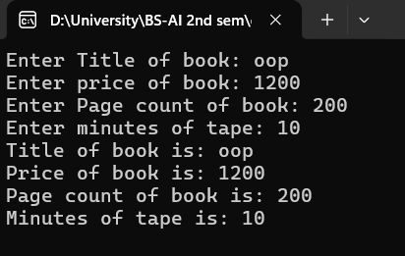 tape haris;

oop.getpublication();

oop.getbook();

haris.gettape();

oop.putpublication();

oop.putbook();

haris.puttape(); }

**program 2:**

#include<iostream>

using namespace std;

class publication {

private:

string title;

float price;

public:

void getpublication(){

cout<<"Enter Title of book: ";

cin>>title;

cout<<"Enter price of book: ";

cin>>price; }

void putpublication(){

cout<<"Title of book is: "<<title<<endl;

cout<<"Price of book is: "<<price<<endl; }

};

class sales {

private:

float arr[3];

public:

void getsales() {

for(int i=0;i<3;i++){

cout<<"Enter sales of month "<<i+1<<": ";

cin>>arr[i]; }

}

void putsales(){

for(int i=0;i<3;i++){

cout<<"Sales of month "<<i+1<<" is ";

cout<<arr[i]<<endl; } }

};

class book:public publication, public sales

{

private:

int page_count;

public:

void getbook(){

cout<<"Enter Page count of book: ";

cin>>page_count; }

void putbook(){

cout<<"Page count of book is: "<<page_count<<endl; }

};

class tape:public publication,public sales {

private:

float minutes;

public:

void gettape(){

cout<<"Enter minutes of book: ";

cin>>minutes; }

void puttape(){

cout<<"Minutes of book is: "<<minutes<<endl; }

};

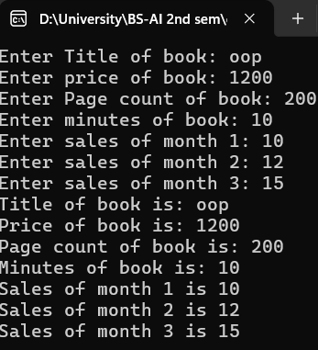int main() {

book oop;

tape haris;

oop.getpublication();

oop.getbook();

haris.gettape();

haris.getsales();

oop.putpublication();

oop.putbook();

haris.puttape();

haris.putsales();

}

**Program 3 :**

#include <iostream>

using namespace std;

class publication {

private:

string title;

float price;

public:

void getpublication() {

cout << "Enter Title of book: ";

cin >> title;

cout << "Enter price of book: ";

cin >> price; }

void putpublication() {

cout << "Title of book is: " << title << endl;

cout << "Price of book is: " << price << endl; }

};

class book : public publication {

private:

int count;

public:

void getbook() {

cout << "Enter Page count of book: ";

cin >> count; }

void putbook() {

cout << "Page count of book is: " << count << endl; }

};

class tape : public publication {

private:

float minutes;

public:

void gettape() {

cout << "Enter minutes of tape: ";

cin >> minutes; }

void puttape() {

cout << "Minutes of tape is: " << minutes << endl; }

};

enum DiskType { CD, DVD,INVALID };

class disk : public publication {

private:

DiskType disk_type;

public:

void getdisk() {

char type;

cout << "Enter disk type (c for CD, d for DVD): ";

cin >> type;

if (type == 'c' || type == 'C') {

disk_type = CD;

} else if (type == 'd' || type == 'D') {

disk_type = DVD;

} else {

disk_type=INVALID; }

}

void putdisk() {

cout << "Disk type is: ";

if (disk_type == CD)

{

cout << "CD"; }

else if (disk_type == DVD) {

cout << "DVD"; }

else {

cout<<"Invalid disk type "; }

}

};

int main() {

book oop;

tape haris;

disk type;

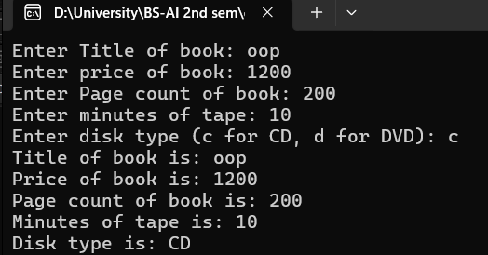 oop.getpublication();

oop.getbook();

haris.gettape();

type.getdisk();

oop.putpublication();

oop.putbook();

haris.puttape();

type.putdisk();

return 0; }

**program 4 :**

#include <iostream>

#include <string>

using namespace std;

enum Period { hourly, weekly, monthly };

class Employee

{

protected:

string name;

long number;

public:

void getdata()

{

cout << "Enter name: ";

cin >> name;

cout << "Enter number: ";

cin >> number; }

void putdata() const {

cout << "Name: " << name << "\n";

cout << "Number: " << number << "\n"; }

};

class Employee2 : public Employee

{

private:

double compensation;

Period period;

public:

void getdata()

{

Employee::getdata();

cout << "Enter compensation: ";

cin >> compensation;

int period;

cout << "Enter pay period (0 for Hourly, 1 for Weekly, 2 for Monthly): ";

cin >> period;

period = static_cast<Period>(period);

}

void putdata() const {

Employee::putdata();

cout << "Compensation: " << compensation << "\n";

cout << "Pay period: ";

switch (period) {

case hourly: cout << "Hourly\n"; break;

case weekly: cout << "Weekly\n"; break;

case monthly: cout << "Monthly\n"; break; }

}

};

class Manager2 : public Employee2

{

private:

string title;

double dues;

public:

void getdata()

{

Employee2::getdata();

cout << "Enter title: ";

cin >> title;

cout << "Enter dues: ";

cin >> dues;

}

void putdata() const {

Employee2::putdata();

cout << "Title: " << title << "\n";

cout << "Dues: " << dues << "\n"; }

};

class Scientist2 : public Employee2

{

private:

int publications;

public:

void getdata()

{

Employee2::getdata();

cout << "Enter number of publications: ";

cin >> publications;

}

void putdata() const {

Employee2::putdata();

cout << "Publications: " << publications << "\n"; }

};

class Laborer2 : public Employee2 {

// No additional data members

};

int main()

{

Manager2 mang;

Scientist2 scient;

Laborer2 labor;

cout << "Enter manager data:\n";

mang.getdata();

cout << "\nEnter scientist data:\n";

scient.getdata();

cout << "\nEnter laborer data:\n";

labor.getdata();

cout << "\nManager data:\n";

mang.putdata();

cout << "\nScientist data:\n";

scient.putdata();

cout << "\nLaborer data:\n";

labor.putdata();

return 0;

}

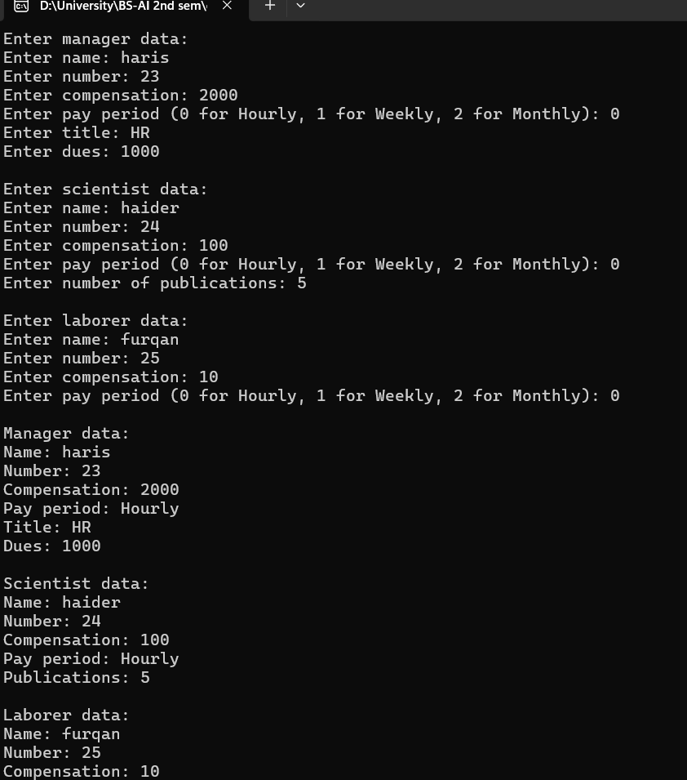

**Program 5 :**

#include <iostream>

#include <cmath>

using namespace std;

class Shape {

protected:

string color;

public:

Shape(const string& color) : color(color) {}

void printColor() const {

cout << "Color: " << color << endl; }

};

class Circle : public Shape {

private:

double radius;

public:

Circle(const string& color, double radius) : Shape(color), radius(radius) {}

double calculateArea() const {

return M_PI * radius * radius;

}

void printArea() const {

cout << "Circle Area: " << calculateArea() << endl; }

};

class Rectangle : public Shape {

private:

double length;

double width;

public:

Rectangle(const string& color, double length, double width) : Shape(color), length(length), width(width) {}

double calculateArea() const {

return length * width; }

void printArea() const {

cout << "Rectangle Area: " << calculateArea() << endl; }

};

int main() {

string color;

double radius, length, width;

cout << "Enter color of circle: ";

cin >> color;

cout << "Enter radius of circle: ";

cin >> radius;

Circle circle(color, radius);

circle.printColor();

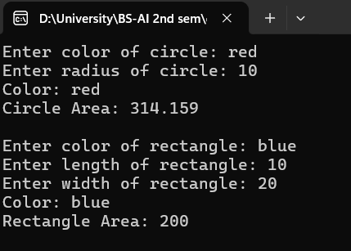 circle.printArea();

cout << "\nEnter color of rectangle: ";

cin >> color;

cout << "Enter length of rectangle: ";

cin >> length;

cout << "Enter width of rectangle: ";

cin >> width;

Rectangle rectangle(color, length, width);

rectangle.printColor();

rectangle.printArea();

return 0;

}

**Program 6 :**

#include<iostream>

using namespace std;

class Employee {

private:

string name, department;

int ID;

public:

void getEmp() {

cout << "Enter Employee Name: ";

cin >> name;

cout << "Enter Employee Department: ";

cin >> department;

cout << "Enter Employee ID: ";

cin >> ID;

}

void putEmp() {

cout << "Employee Name: " << name << endl;

cout << "Employee Department: " << department << endl;

cout << "Employee ID: " << ID << endl;

}

};

class SalariedEmployee : public Employee {

private:

int salary;

public:

void getSalariedEmp() {

cout << "Enter Employee Salary: ";

cin >> salary;

}

void putSalariedEmp() {

cout << "Employee Salary: " << salary << endl;

}

};

class CommissionedEmployee : public Employee {

private:

int salary;

float comirate;

public:

void getCommissionedEmp() {

cout << "Enter Employee Salary: ";

cin >> salary;

cout << "Enter Employee Commission Rate (%): ";

cin >> comirate;

}

void putCommissionedEmp() {

float commission = (salary * comirate) / 100;

float totalSalary = salary + commission;

cout << "Employee Salary after commission: " << totalSalary << endl;

}

};

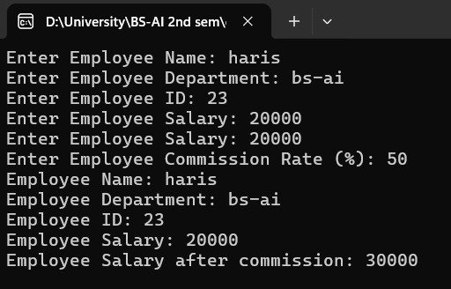

int main() {

SalariedEmployee obj;

CommissionedEmployee obj1 ;

obj.getEmp();

obj.getSalariedEmp();

obj1.getCommissionedEmp();

obj.putEmp();

obj.putSalariedEmp();

obj1.putCommissionedEmp();

return 0;

}